Programming Assignment 1 Instructions

Create a Visual Basic form like the one below that allows the user to press buttons to change the background and foreground colors of the textbox and update a text box. Your form should have 3buttons, 1 label, and 1 textbox. Name the initial form frmAssignment_1 and put Assignment #1 in its title bar.
- Name the buttons btnUpdateFont, btnUpdateVerse, btnVerify. The tab order of the buttons should be Update Verse, Update Font, and Update Verify. The tab should not go to the textbox. The form should open with the Update Verse button having the focus.
- Create access keys for the buttons with the “U” underlined for the Update Verse and the F underlined for the Update Font buttons. Create an access key for the “V” underlined on the Verify button.
- Name the textbox txtVerse and enter into it the Bible verse from Phil 4:13 as depicted below. The font of the textbox should be something other than the default Microsoft Sans Serif. The text should be center aligned.
- When the user clicks the Update Font Button, the background of the textbox should become blue (use Color.Blue), the foreground of the textbox should become red (use Color.Red) and the Background color of the form should become whte (use color.white)
- When the user clicks the Update verse button, Your favorite verse should be displayed in the txtverse text box.
- A label should be created called lblVerify. The label should be created but not show on the load.
- When the user clicks the Verify button the label text should now be visible to the user. The label should include your name and your teacher name and the date you finished your project.. **This is a main requirement and the assignment will not be accepted without this detail.

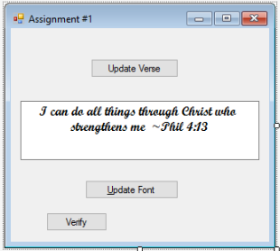

This assignment is due by 11:59 p.m. (ET) on Monday of Module/Week 1.

